BACCALAURÉAT GÉNÉRAL ET TECHNOLOGIQUE

Session 2012

ÉPREUVE SPÉCIFIQUE MENTION « SECTION EUROPÉENNE OU DE LANGUE ORIENTALE »
Académies de Paris-Créteil-Versailles

Binôme : Anglais / Mathématiques

CORE KNOWLEDGE
Sujet D0 - 09

Global Inequality
The following data is taken from a report published in 1992 by the UNDP (United Nations Development Programme).
Part A : Distribution of global income
The following table gives the distribution of the world’s global income for different years.

Year | Poorest | Second | Third | Fourth | Richest | Ratio of the richest
 | 20 % | 20 % | 20 % | 20 % | 20 % | to the poorest
1965 | 2.3 | 2.9 | 4.2 | 21.1 | 69.5 | 30 to 1
1970 | 2.2 | 2.8 | 3.8 | 21.2 | 70.0
1980 |  | 2.2 | 3.5 | 18.3 | 74.1
1990 | 1.4 | 1.8 | 2.1 | 11.3

For example, in 1965, the poorest 20 % owned only 2.3 % of the world’s global income, whereas the richest 20 % owned 69.5 % of the world’s global income.
1.
(a) What percentage of the world’s global income did the poorest 20 % own in 1980 ?
(b) What percentage of the world’s global income did the richest 20 % own in 1990 ?
2.
(a) Why is the “ratio of the richest to the poorest” equal to “30 to 1” in 1965 ?
(b) Work out the ratios for the other years.
3. The report says that “global inequality doubled between 1965 and 1990”.
True or false ? Justify.

Part B : The Gini Coefficient
Another way of measuring inequality is the Gini Coefficient.
1. First fill in the following cumulative percentage table corresponding to 1990:

Cumulative | Lowest | Lowest | Lowest | Lowest | Lowest
population % | 20 % | 40 % | 60 % | 80 % | 100 %
Cumulative | 1.4 | 3.2
income (%)

2. The data in this table is then plotted in a graph, as shown below:

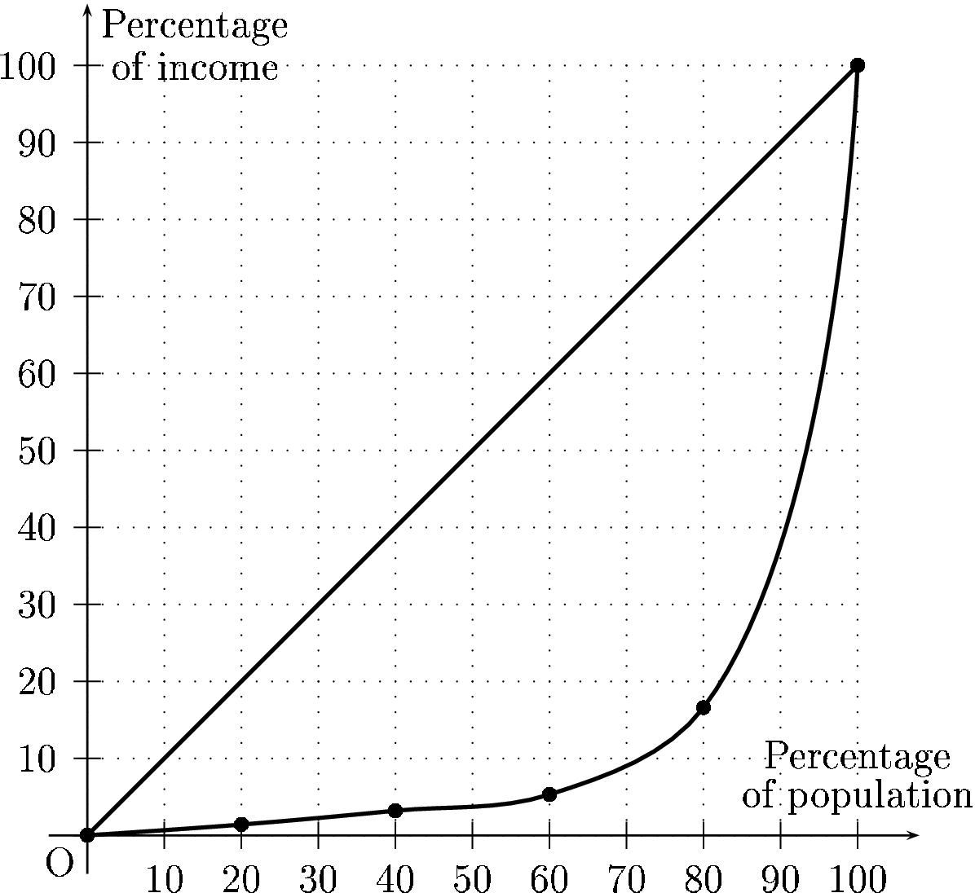

The Gini Coefficient is the ratio of the area between the curve and the diagonal line divided by the area of the triangle below the diagonal.
This coefficient can vary between 0 (perfect equality) and 1 (extreme inequality).
(a) What is the area of the triangle below the diagonal?
(b) Can you give an approximate value of the area below the curve?
(c) Compute the Gini Coefficient for 1990 and comment on your result.

