BaccalaurÉat gÉnÉral et technologique

Session 2012

ÉPREUVE SPÉCIFIQUE MENTION « SECTION EUROPEENNE OU DE LANGUE ORIENTALE »
Académies de Paris-Créteil-Versailles

Binôme : Anglais / Mathématiques

SEQUENCES
Sujet D3 - 23

The first part of this page is a summary that can help you do the exercise.

Arithmetic and geometric sequences

An arithmetic progression (A.P.) is a sequence in which each term after the first is formed by adding a fixed amount called the common difference to the preceding term.
If a₁ is the first term and d is the common difference, the nth term is: a_{n} = a₁ + (n-1)d .

A geometric progression (G.P.) is a sequence in which each term after the first is formed by multiplying the preceding term by a fixed number, called the common ratio.
If a₁ is the first term and r is the common ratio, the nth term is: a_{n} = a₁ r^{n-1}.

The Towers of Hanoi
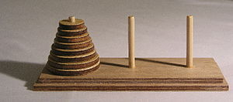
The Towers of Hanoi is a mathematical game. It is made of three rods and a number of disks of different sizes which can slide onto any rod. When the puzzle starts the disks are in a neat stack on the first rod and ordered according to their size, the smallest being at the top.

The objective of the puzzle is to move the entire stack to the last rod, obeying the following rules:
- only one disk may be moved at a time from one rod to another;
- no disk may be placed on top of a smaller disk.
For example, with 2 disks the solution using as few steps as possible is as follows:
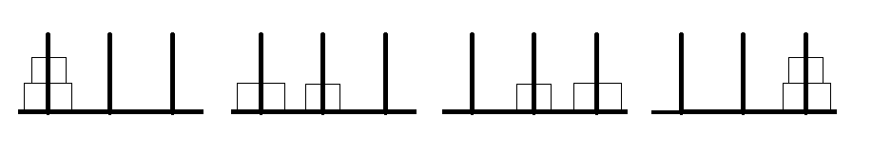
The minimal number of moves required to solve a Tower of Hanoi puzzle is , n being the number of disks.
- Can you find a solution for 3 disks?
- According to an ancient Indian prophecy, solving a Towers of Hanoi puzzle with 64 disks will lead to the end of the world.
- How many moves will it take to solve this puzzle?
- If a move takes a second, how long will it take before the world comes to an end?
Give the exact solution in seconds and then an approximation in years.

- Use the following drawing to explain how to find a link between the solution with n-1 disks and the solution with n disks.
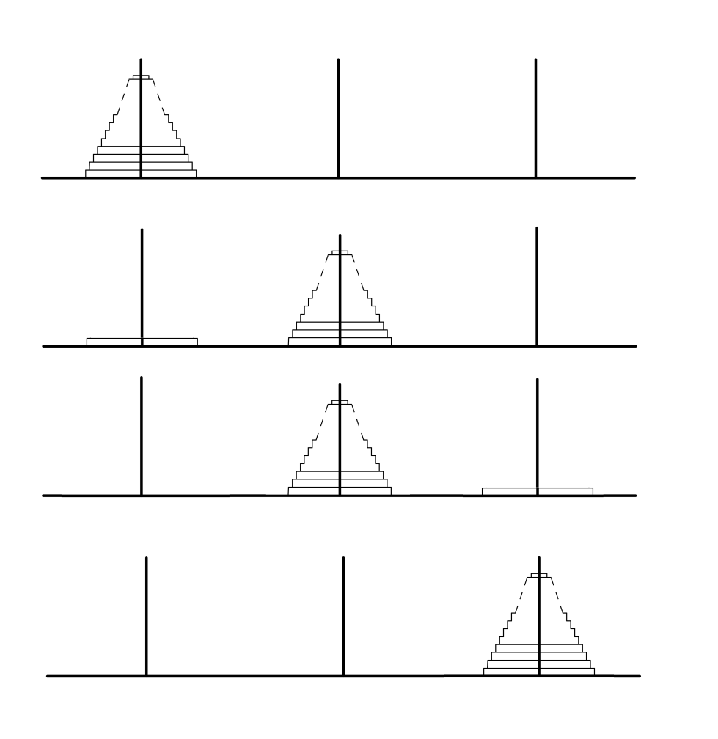
n
n-1
n-1
n
Step 3
Step 1
Step 0
Step 2
b) Let n be the number of disks and u_{n} the minimum number of moves needed to solve the
puzzle. Find a link between u_{n-1} and u_{n}. Is u_{n} an arithmetic sequence or a geometric
sequence?

