BaccalaurÉat gÉnÉral et technologique

# Session 2012

## ÉPREUVE SPÉCIFIQUE MENTION « SECTION EUROPEENNE OU DE LANGUE ORIENTALE »

Académies de Paris-Créteil-Versailles

**Binôme : Anglais / Mathématiques**

**CORE KNOWLEDGE**

**sujet D0-15**

*The first part of this page is a summary that can help you do the exercise.*

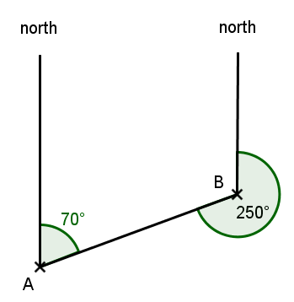**Bearings**

A bearing is an angle, measured clockwise from the north

direction.

The bearing of B from A is 070 degrees (note that 3 figures

are always given) as shown in the diagram.

**Solving triangles**

In a right-angled triangle trigonometric ratios can be used:

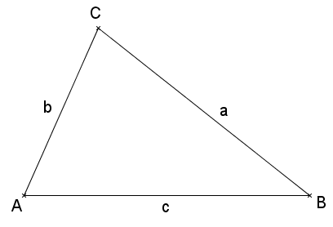  

Otherwise, triangles may be solved using the following formulas:

**Sine rule :** 

**Cosine rule :**  .

**Exercise** : The map below gives the position and direction of several airplanes. The grid lines radiate at 10° intervals, the dashed lines from Paris and the solid lines from the airport.

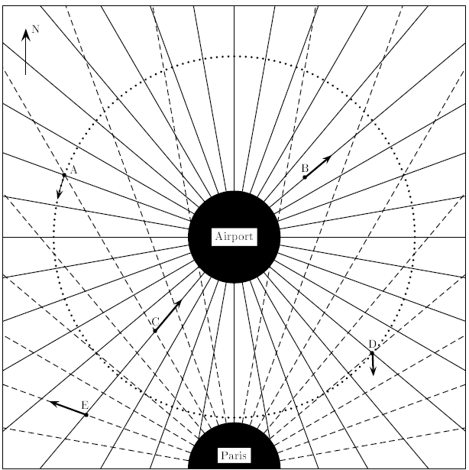

1. Airplane positioning:
   1. Which airplane is positioned on a bearing of 220° from the airport and on a bearing of 330° from Paris?
   2. Using the same process, give the position of airplanes **A** and **E**.
   3. From which airplane is the airport on a bearing of 40° and Paris on a bearing of 110°?
2. Position of airplane **D** from airplane **A**.
   1. Find the bearing of airplane **D** from airplane **A**.
   2. Given that **A** and **D** are both 80 kilometers away from the airport, calculate the distance between these two airplanes.