BaccalaurÉat gÉnÉral et technologique

Session 2012

ÉPREUVE SPÉCIFIQUE MENTION « SECTION EUROPEENNE OU DE LANGUE ORIENTALE »
Académies de Paris-Créteil-Versailles

Binôme : Anglais / Mathématiques

STATISTICS
Sujet D7 – 22
The first part is a summary that can help you do the exercise.

The running total of the frequencies at the end of each class interval is called the cumulative frequency. Cumulative frequency provides a convenient way of estimating a median (when the distribution is split into 2 parts), quartiles (when the distribution is split into 4 parts) and deciles (when the distribution is split into 10 parts) without considering the raw data.
We can estimate the median on the horizontal axis of the graph by reading the half-way value on the vertical axis.
The arithmetic mean of the values x₁, x₂, …., x_{p} whose corresponding frequencies are n₁, n₂, …., n_{p}, is
$\overline{x}$ = $_{\frac{n1x1+n2x2+….+npxp}{n1+n2+….+np}}$ .
The weight (in kilograms) of 80 boys was recorded and the results are shown in the following cumulative frequency diagram.

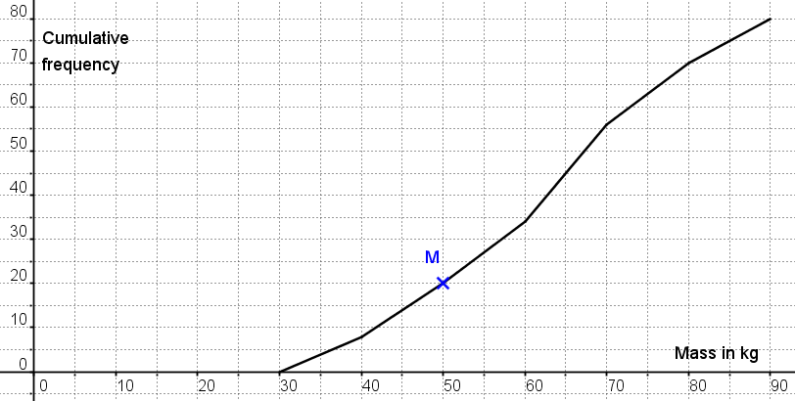

- Point M(50,20) belongs to the curve. Explain what information this gives us.

- Find an approximate value, to the nearest kg, of:
  - the median;
  - the lower quartile;
  - the interquartile range.
Justify your answers.

- How many boys weigh more than 60kg?

  - Use the cumulative frequency graph to complete this frequency table.
Mass, m | Frequency
 | 8
 | 14
 | 22
 | 10
  - Calculate an estimate of the mean mass, rounded to 1 d.p.

